**Assignment 4: Angular**

Name: Wildan Luqmanul Hakim

**Project Scenario**

You have been approached by a Car Dealership company XYZ Cars. As part of their new initiative, you are asked to set up a basic Angular application to which Angular components will be added. You are supposed to setup a Angular environment.

1. **Setup NodeJs**

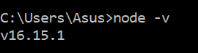

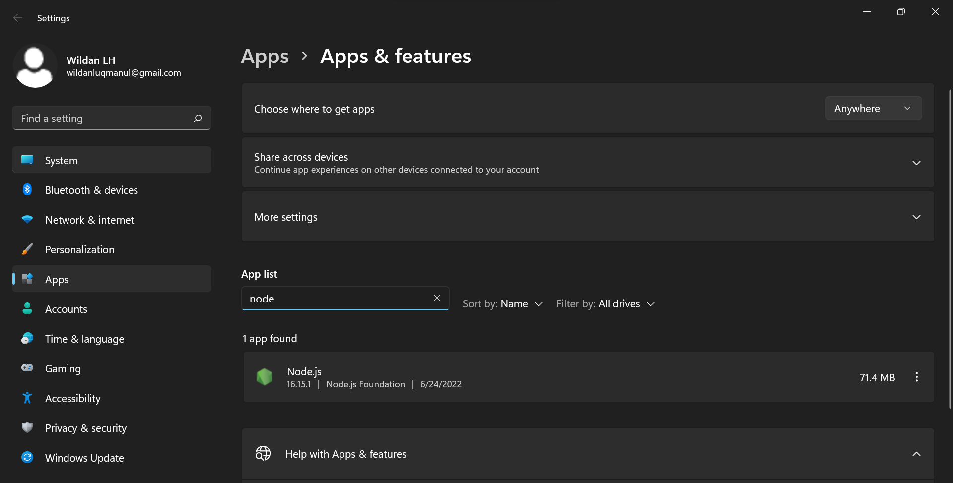

1. **Setup an Angular Project using Angular CLI**

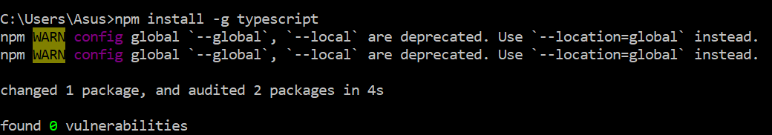

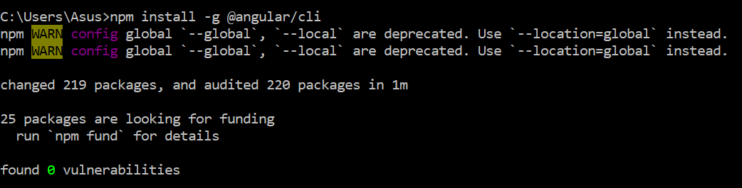

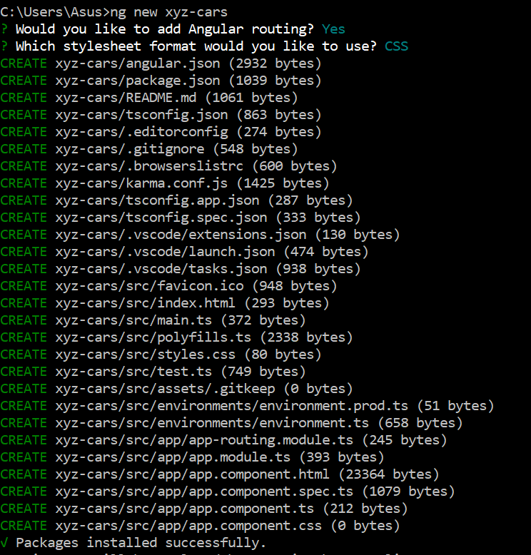

1. **Run the Angular Project using ng serve --open**

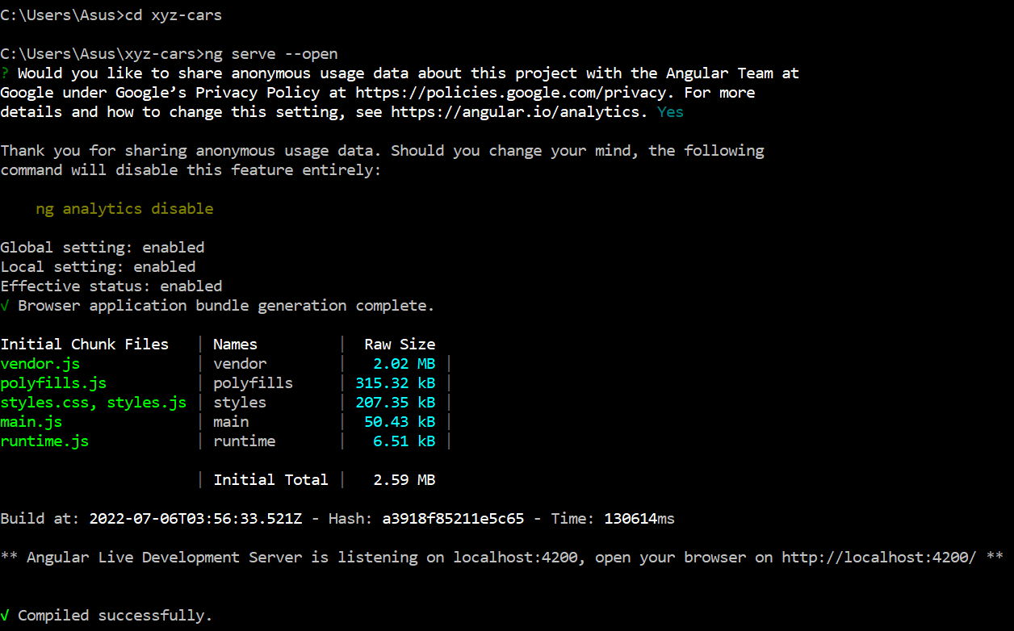

1. **Provide the script to generate an Angular Component using Angular CLI**

ng generate component <component name>

ng g c <component name>

1. **Generate an Angular Component called WelcomeComponent**

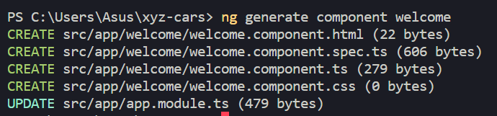

1. **Include the text “Welcome to XYZ Cars…” in the Component**

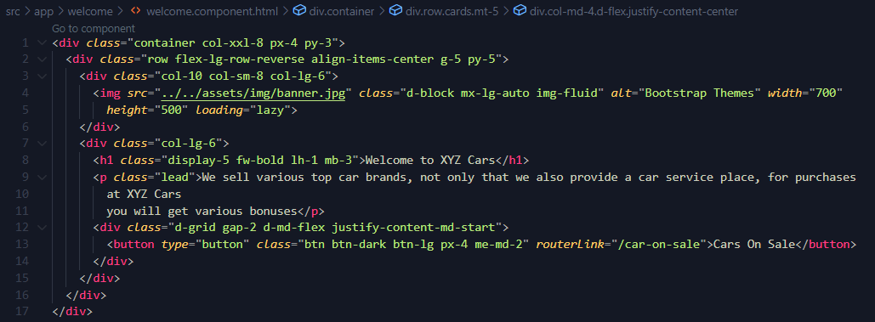

1. **Include the Component created as part of AppComponent**

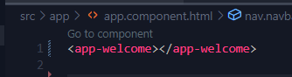

1. **Create 2 Components**

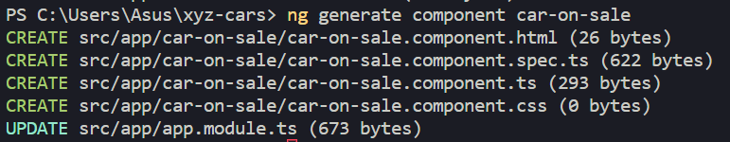

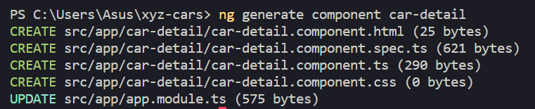

* 1. **One for displaying Cars On Sale**

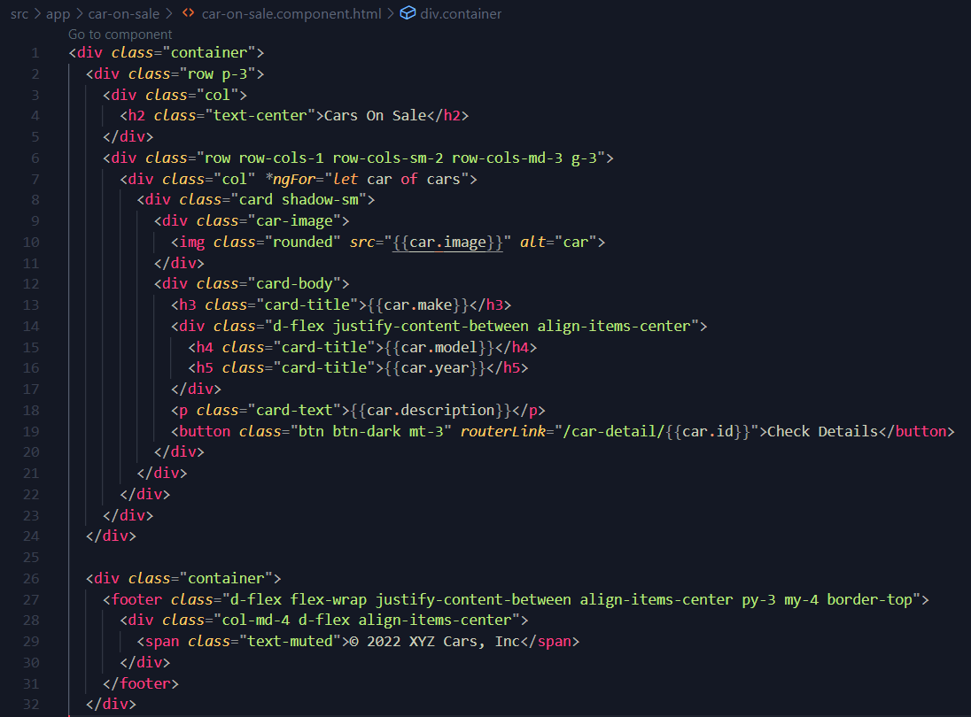

* 1. **Detail of a Car which is being clicked**

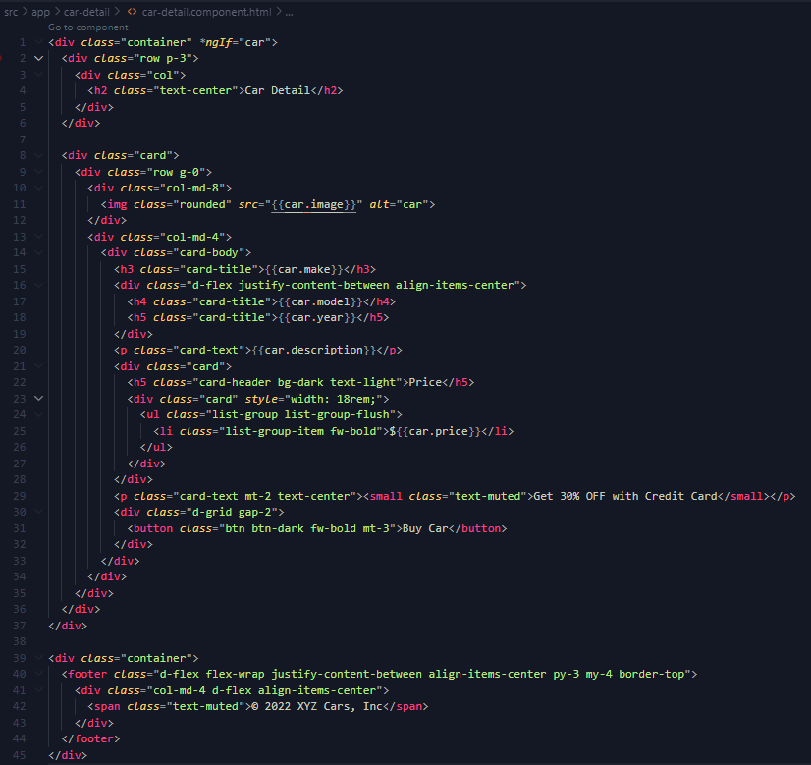

1. **Configure 2 Routes**

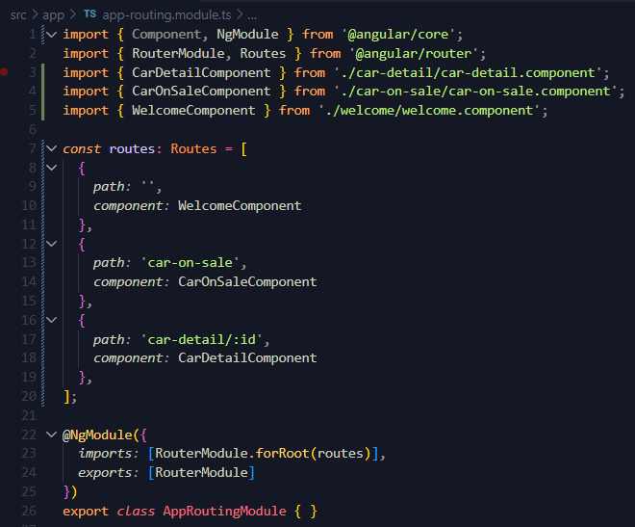

1. **Create a Custom Service to provide test Car Data with 3 fields, Make, Model, Year, Description & Car Photo & subscribe to the service**

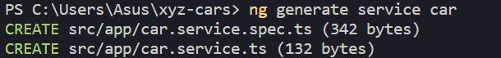

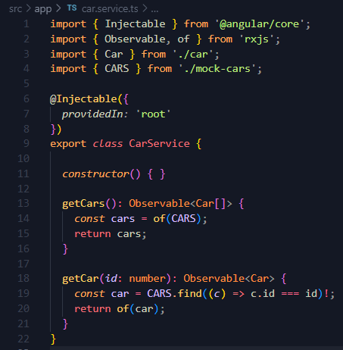

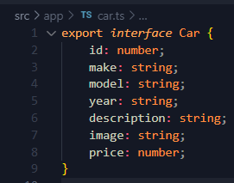

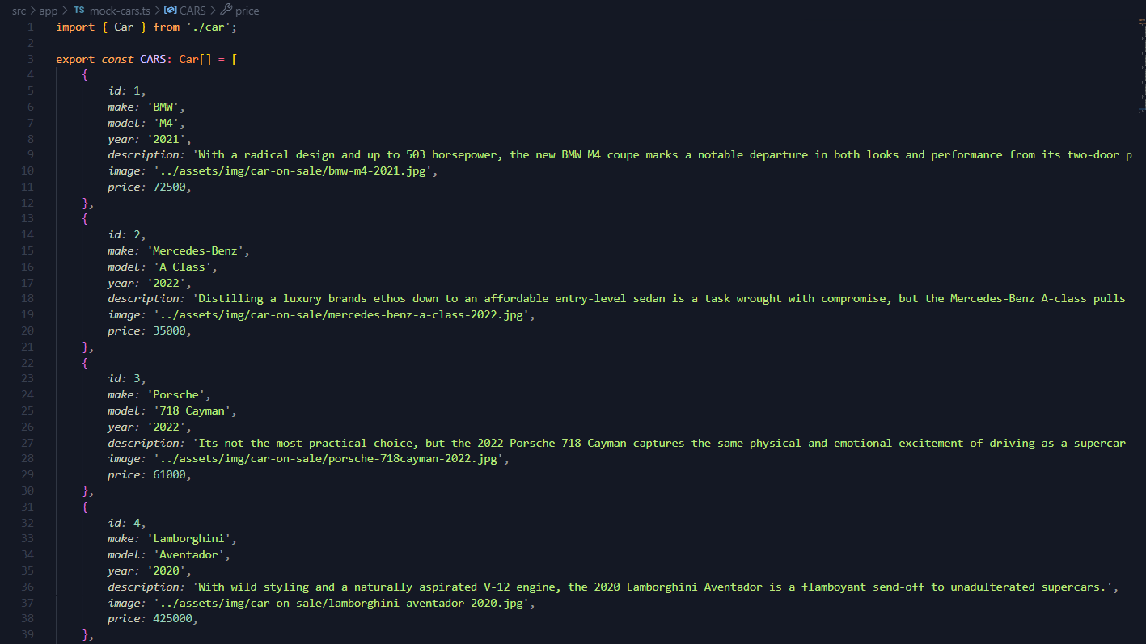

1. **Include the 2 Components in the AppComponent**

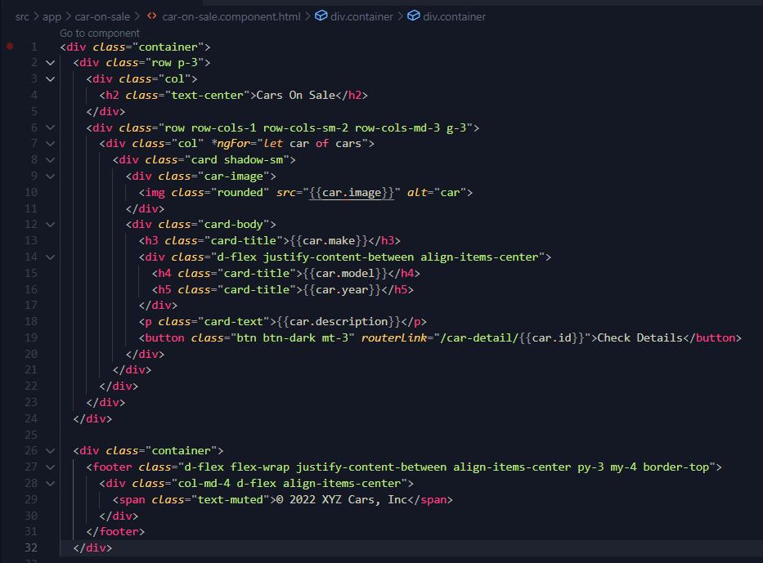

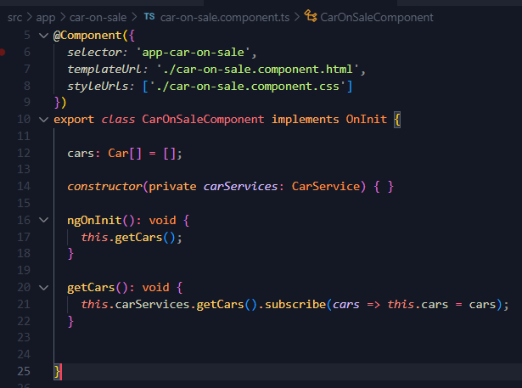



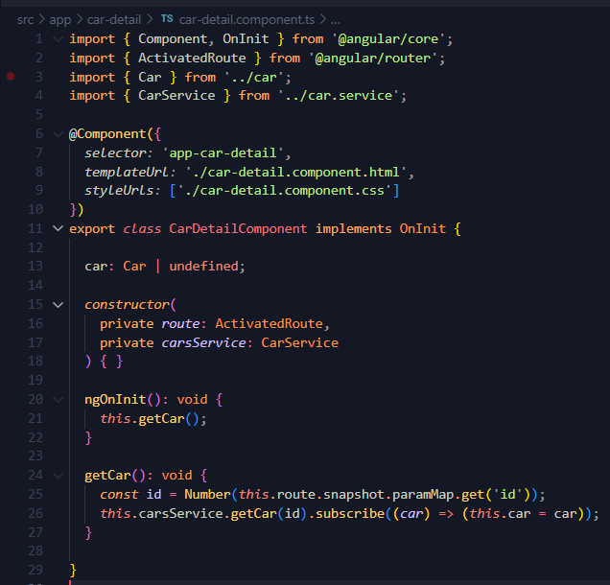

1. **The final project should have a Welcome Screen, List of Cars Screen and Car Detail Screen**

**Provide screen capture & Sources**

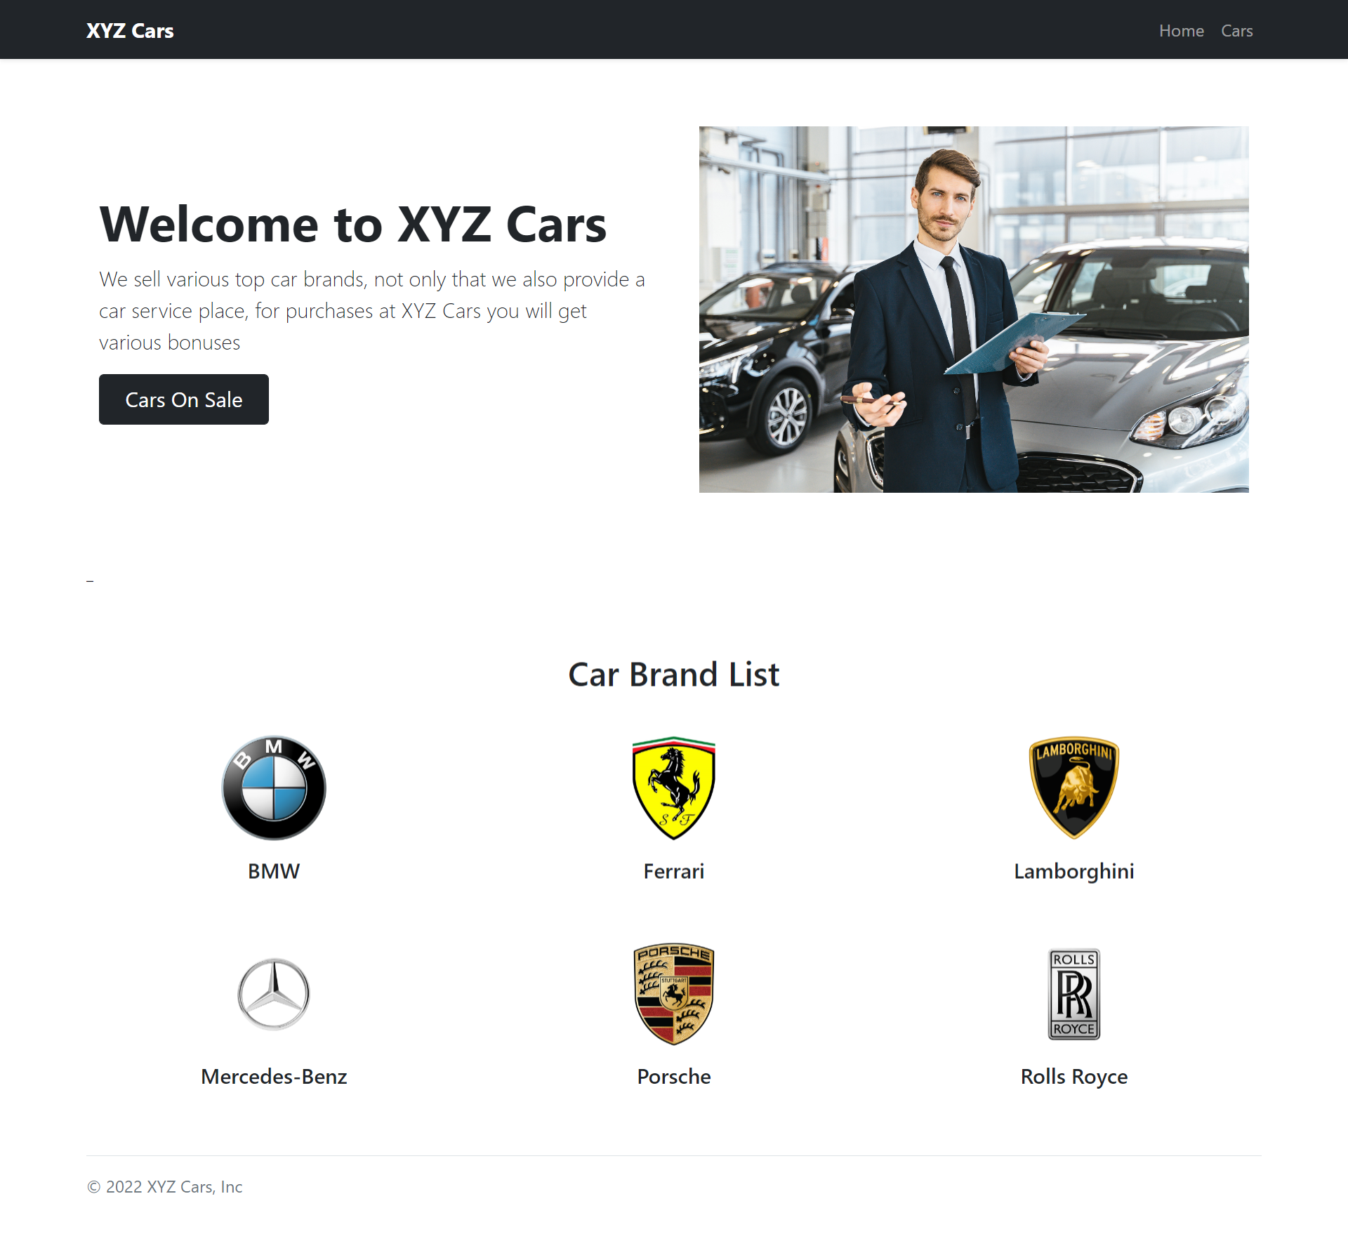

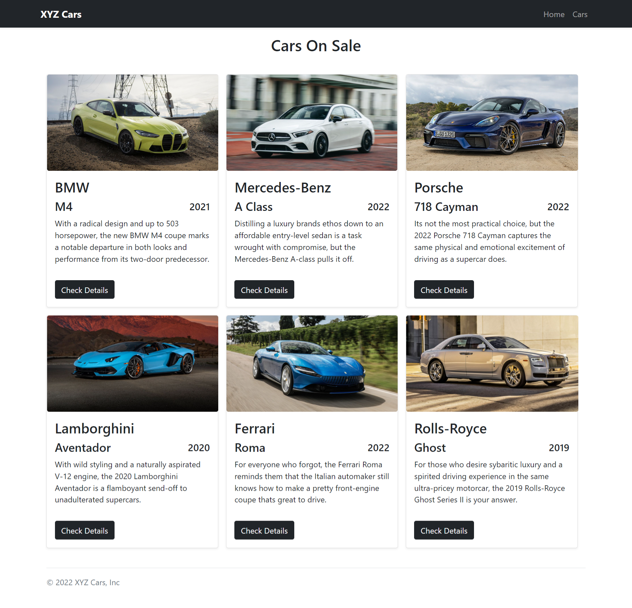

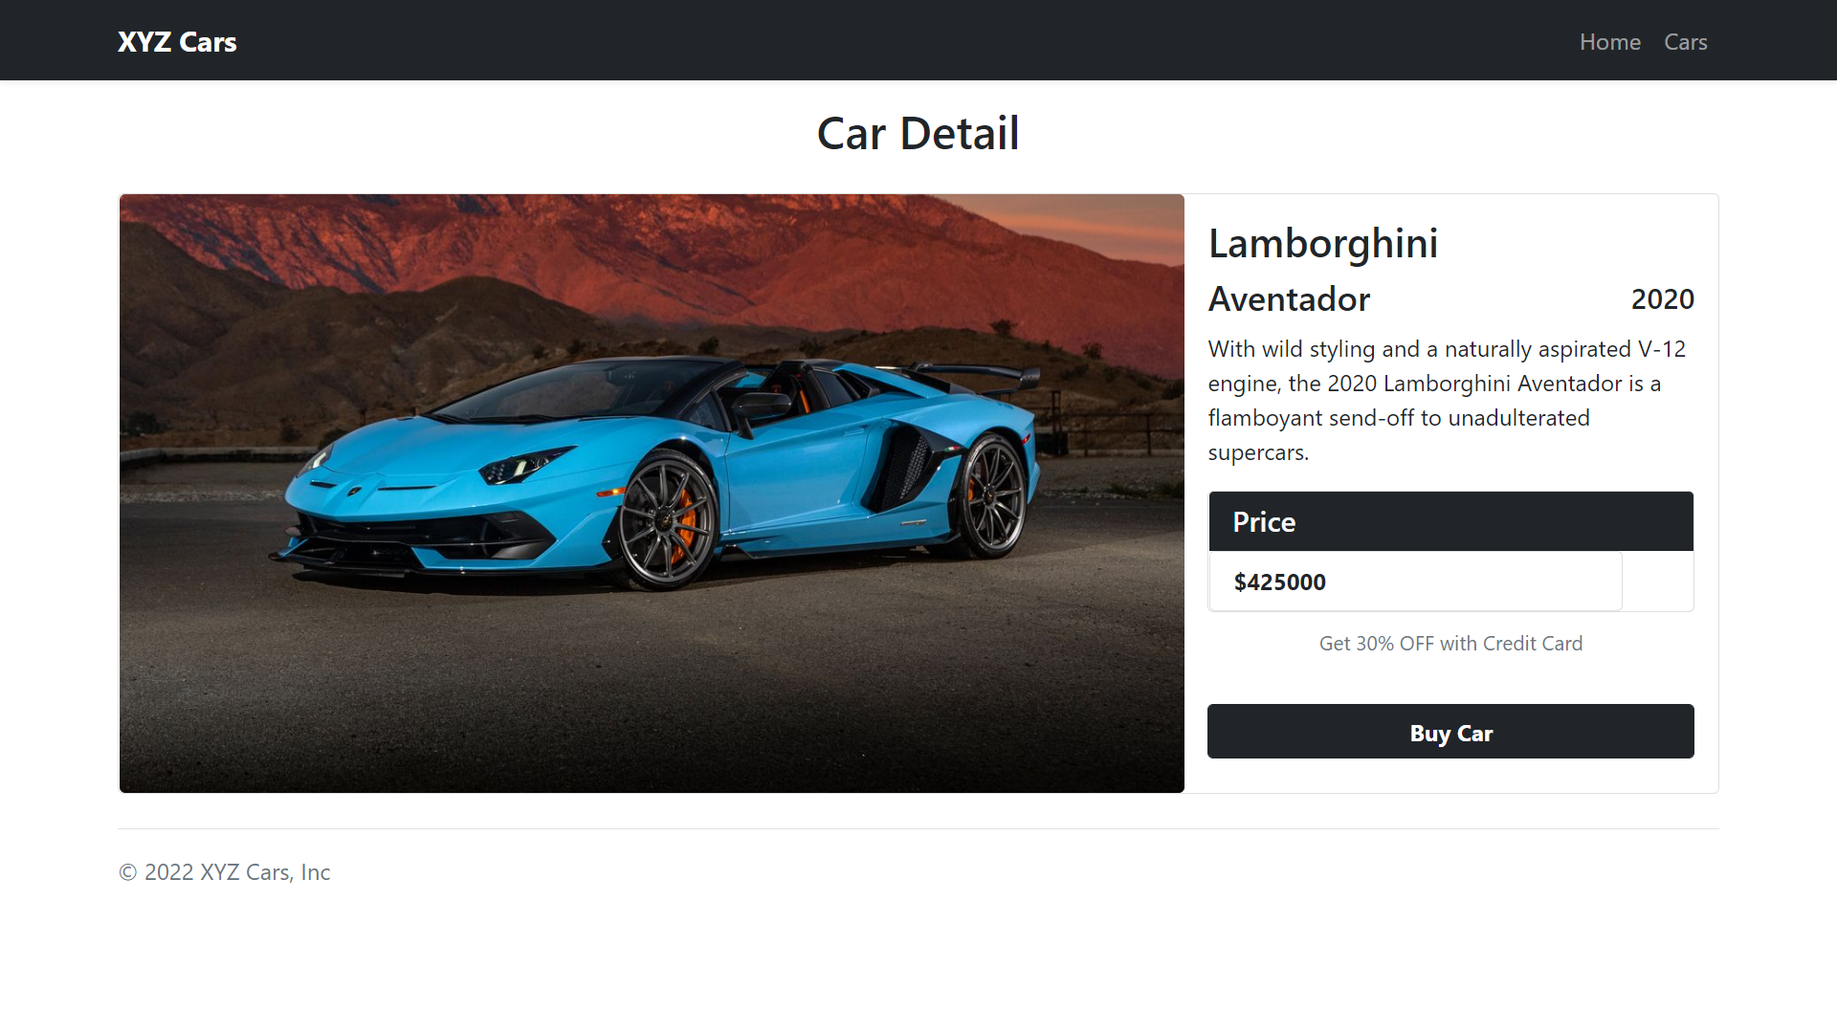

**Zip File**

